LAB NO: 7

LAB AIM: To implement the Naïve Bayes Classification algorithm using suitable
dataset.

DATASET AND RESOURCES : Raisin_dataset from classroom and Python/Jupyter Notebook

DATE OF PERFORMANCE:09 - 10 -2026

GITHUB REPO LINK :
https://github.com/Prabhkirat-Singh-Marwah/ML-PRACTICALS/tree/main/Practical-07

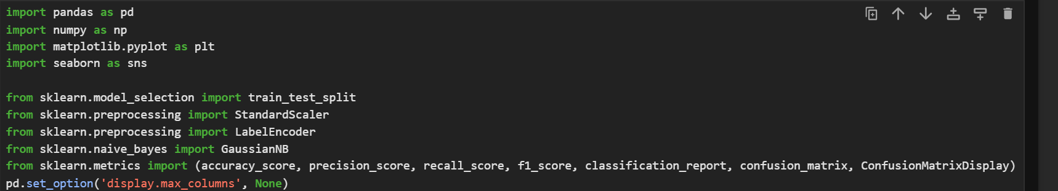this command imports all the libraries needed for out code to run properly

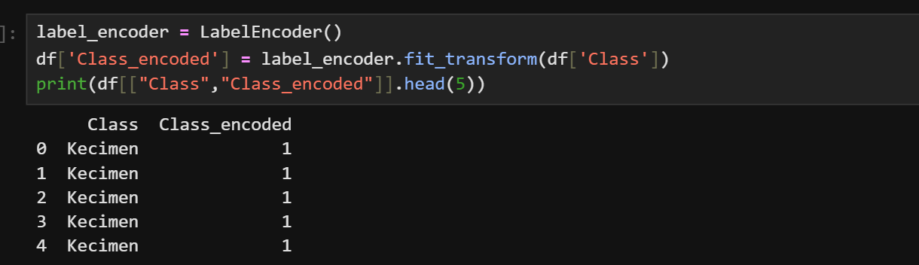this command gives binary value 0 and 1 to raisin types instead of names.

This selects only the columns that contain numbers (like size and area measurements).
These will be used as the input features for the model.

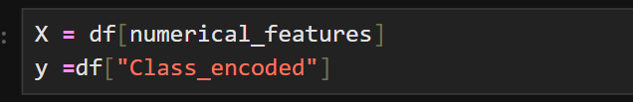
This command divided columns of dataset into input as X and output as y

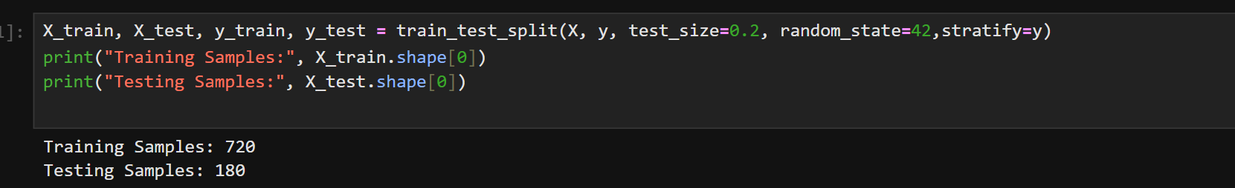
This command divides dataset into training and testing split of 80 and 20.

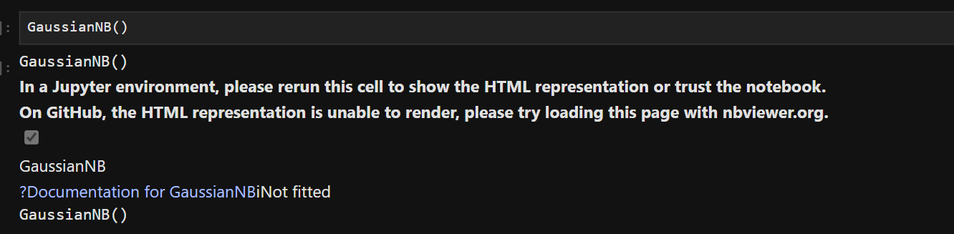
This command creates a baysian model

This command trains the baysian model on the training and testing data which we divided the dataset into earlier.

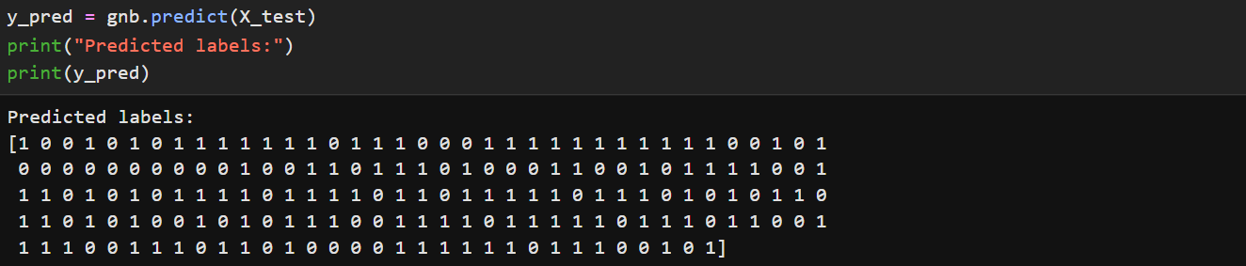

The trained model now predicts the class for the unseen test data.

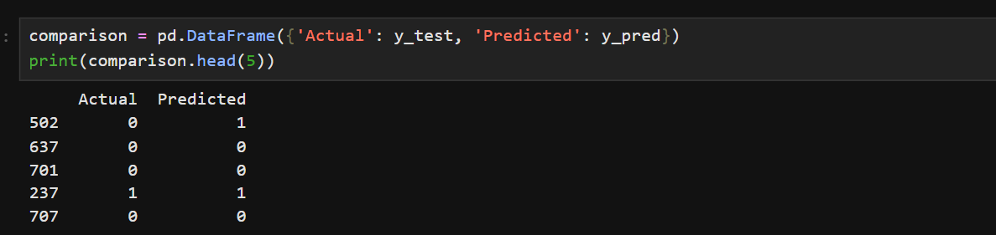
This command helps us see the predicted and actual values side by side

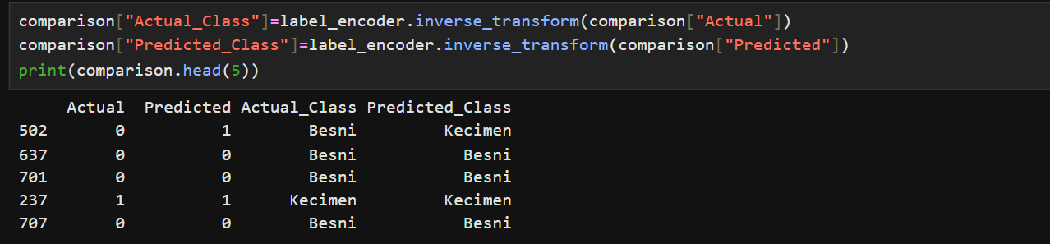
This commands print same as above but with actual values instead of just the binary values which we earlier denoted them using encoding
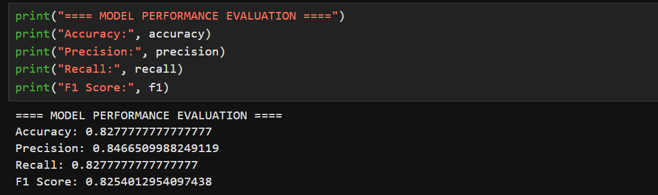
This command prints the basic metrics like recall, precision, f1score and accuracy for our model based on the predicted values and actual values ,

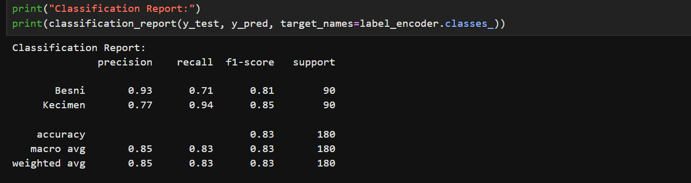
This command prints same metrics but for each class of raisins for better accuracy of each raisin class

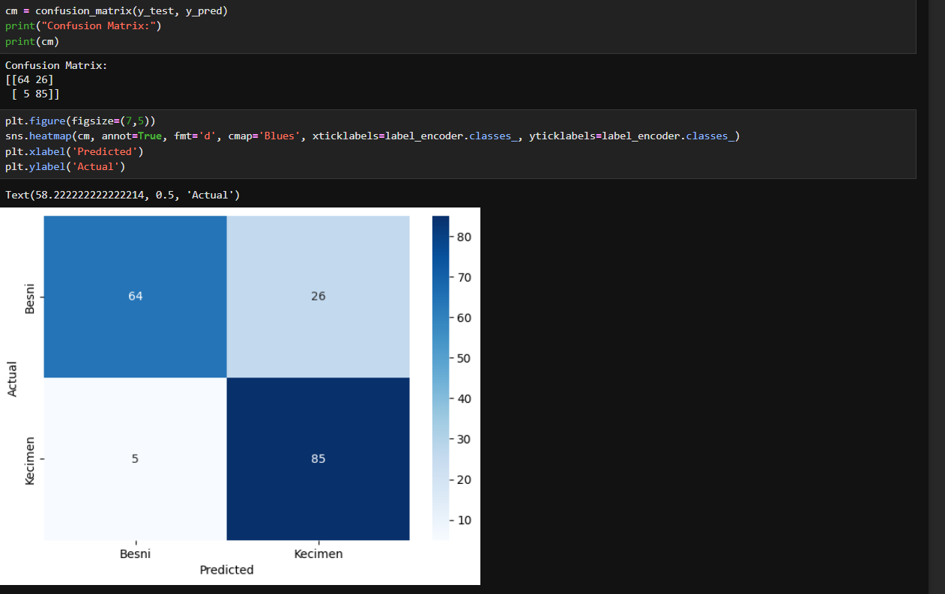
This command prints the confusion matrix and also visual show for same confusion matrix for better understanding.

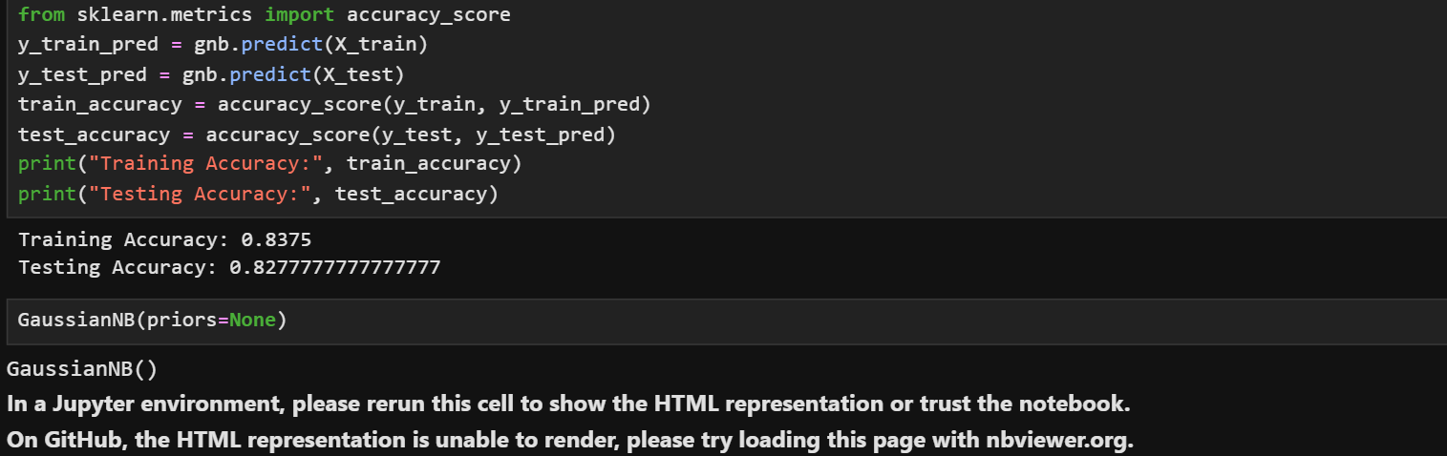
This command prints the testing and training accuracy for our training baysian model.

VIVA QUESTIONS
Q1. What does LabelEncoder do in your code?
It converts the text class names (the two raisin types) into numbers, 0 and 1. This is needed because the model works with numbers, not text.

Q2. Why did you use train_test_split with test_size=0.2?
It keeps 80% of the data for training the model and 20% for testing it on unseen data. This shows how well the model works on new data.

Q3. What is the difference between fit() and predict()?
fit() trains the model using the training data (X_train, y_train). predict() uses the trained model to guess the class of new data (X_test).

Q4. Why did you use GaussianNB for this dataset?
Gaussian Naive Bayes works well when the features are continuous numbers, like the raisin size and shape measurements. It assumes each feature follows a normal (bell-curve) distribution.

Q5. What does confusion_matrix(y_test, y_pred) show?
It shows how many predictions were correct and how many were wrong for each class. The diagonal numbers are correct predictions and the rest are mistakes.

